Get To Know Your Stock: Walt Disney Company

If Walt Disney had more carefully read a contract early in his career, he might’ve ended up building his entertainment empire around Oswald the Lucky Rabbit. But his distributor snagged the rights to Oswald so the cartoonist went back to the drawing board and in 1928 “gave birth” to Mickey Mouse.

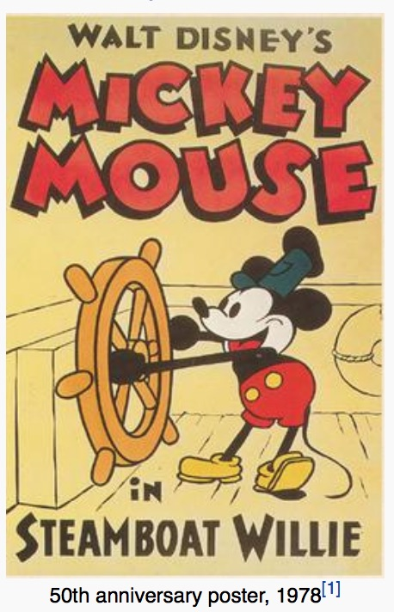
Walt was just 21 when he and his older brother Roy launched the Walt Disney Company in 1923 (initially called Disney Brothers Cartoon Studio). They rented space for a couple of years in the back of a real estate office in Hollywood, Calif., before getting their own place. Disney had a hard time selling its silent cartoon movies because talkies were becoming the rage. So it turned on the volume in its third film, Steamboat Willie, which introduced the world to Mickey and his beloved Minnie Mouse.

Disney soon rolled out a growing cast of characters and Oscar-winning movies. According to the company, its 1937 film Snow White was the highest grossing movie of all time until Gone With the Wind eclipsed it in 1940. During World War II, the U.S. Government asked Disney to make numerous training and propaganda films, which kept the studio humming. Mickey Mouse, Donald Duck and other animated stars entertained U.S. troops who had grown up watching them.

In the 1950s, Disney launched the popular children’s television show The Mickey Mouse Club and a string of live-action box office hits. The Disneyland theme park opened its doors in Southern California in 1955 and by 1971 welcomed its 100,000,000th guest. Walt spent the early 1960s secretly gobbling up 28,000 acres in swampy Orlando, Florida, to develop a larger theme park. He died in 1966, but the company opened Walt Disney World in 1971.

Disney, which joined the Dow Jones Industrial Average in 1991, has over the years expanded across multiple continents and business segments. Shanghai Disneyland opened in June 2016, joining Tokyo Disneyland (1983), Disneyland Paris (1992) and Hong Kong Disneyland (2005). The company also operates a resort in Hawaii and a cruise line that has its own private island in the Bahamas.

Disney’s 1995 takeover of Capital Cities/ABC created the world’s most powerful media and entertainment entity. Pixar Animation Studios joined the Disney family 10 years ago. The company’s other subsidiaries include Touchstone Pictures and Marvel Entertainment. Disney has also racked up Tony awards on Broadway and it currently operates about 350 retail stores worldwide.

Following the success of its 1992 movie The Mighty Ducks, Disney founded and briefly owned the Mighty Ducks professional ice hockey team (now called the Anaheim Ducks). Disney owned the Anaheim Angels professional baseball team in the late 1990s and early 2000s. It currently owns 80% of leading sports network ESPN. Disney recently took a $1 billion stake in BAMTech, a technology spinoff of MLB Advanced Media (the digital media company of Major League Baseball).

And to think, it all began with a nearly 90-year-old mouse. Or rabbit.

