Get To Know Your Stock: Deere & Company

Deere & Co. (NYSE: DE), the world’s largest farm equipment maker and a major producer of construction, forestry and lawn equipment, has had to plow through some difficult times during its 177-year history.

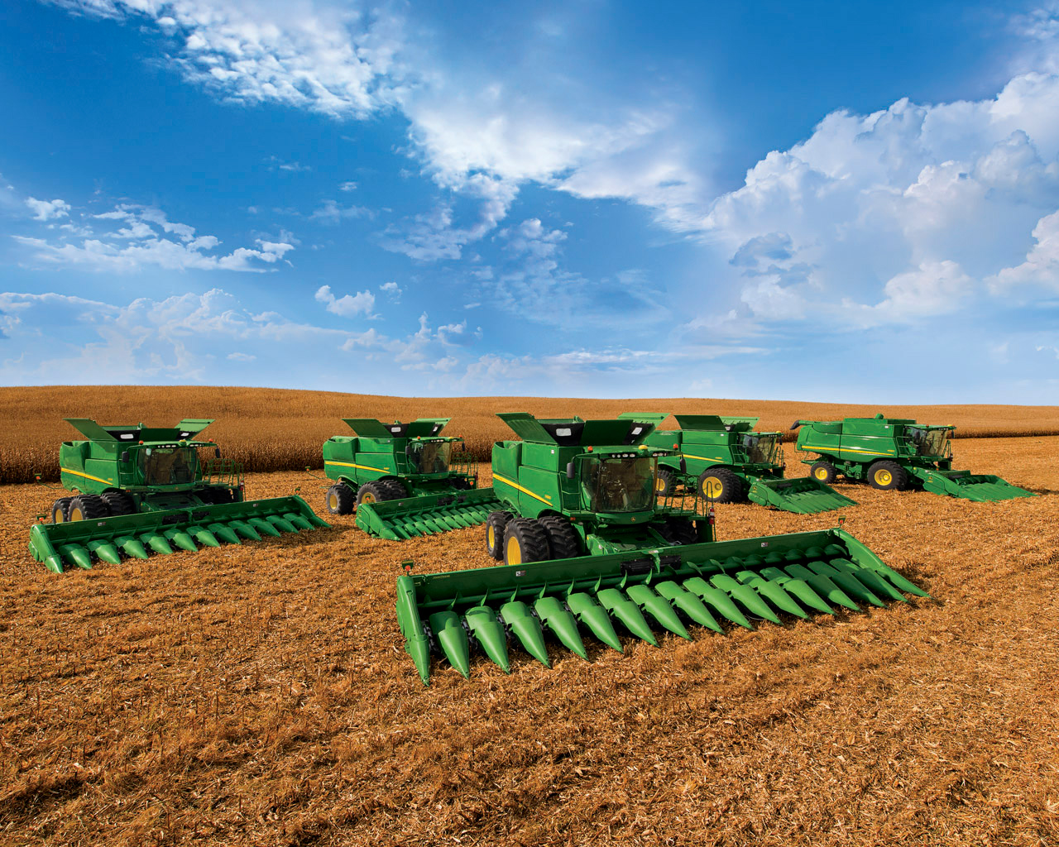
John Deere, a barely-educated blacksmith whose name ranks among today’s most-recognized global brands, was saddled with debt and facing bankruptcy when he left his native Vermont and headed west to Illinois for a fresh start. He immediately built a new blacksmith shop and, in 1837, designed a polished-steel plow to help the fast-growing population of Midwest farmers. He soon started manufacturing plows and added retailing to his business.

Although the company grew rapidly—according to its timeline, Deere’s workforce built 2,136 plows in 1849—the Panic of 1857 led its founder again to the brink of bankruptcy. Other problems that plagued Deere & Co. over the years included the Great Depression and farm problems in the 1930s, antitrust legislation and complaints, global depression in the 1980s and fierce international competition.

Still, the company, which Deere family members continued to lead through the early 1980s, zipped ahead with forward-thinking vision. It began making tractors in the early 1900s and combines, which harvest grain, in the 1920s. Its policy during the Great Depression that permitted many farmers’ receivables to be held in abeyance further strengthened customer loyalty, according to the book John Deere’s Company by Wayne G. Broehl, Jr.

Over the years, Deere & Co. broadened its product lines to include earthmoving and construction machinery, snow blowers, and insurance and financial services divisions. [Trivia tidbit: It briefly produced bicycles in the 1890s and 1970s.]

Today, the company’s operations are divided into three business segments: agriculture and turf (which accounts for the vast majority of its net sales and net income), construction and forestry, and financial services. It’s now a top-10 provider in the crop insurance business, which it entered eight years ago.

Deere & Co. made its first sale in Russia in 1910 and expanded widely around the globe in the 1970s. By 2018, Deere expects half its sales will be coming from overseas sources. According to its website, it has more than 67,000 employees in 42 countries. Meanwhile, the John Deere- Augusta factory in Georgia just hit a milestone, producing its one-millionth tractor.

Deere & Co. reported its second-highest annual total profits for the 2014 fiscal year (which ended October 31). "Even with a significant decline in sales and a continued pullback in the global agricultural sector, John Deere expects to remain solidly profitable in 2015,” said chairman and CEO Samuel R. Allen in the press release.

Longer term, management expects two major factors to fuel strong global growth opportunities for the company. First, agricultural output must double by 2050 to feed a world population that will exceed 9 billion, up from roughly 7 billion today.

Second, massive migration from rural areas to cities is creating the need for infrastructure development. More than 50% of the global population currently lives in urban areas and this is expected to top 70% by 2050.

